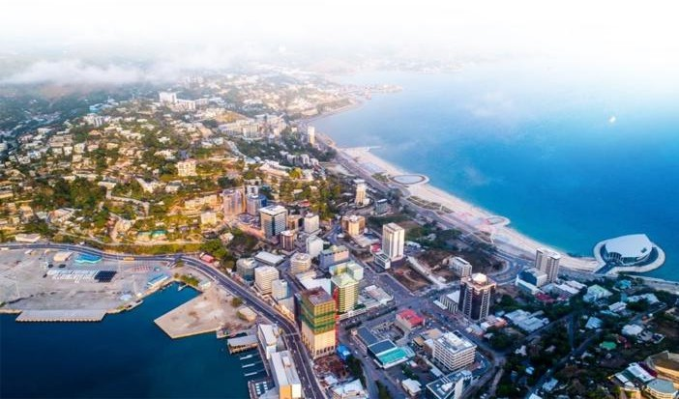
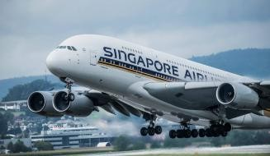



Company Profile



Your Journey, Our Commitment

COMPANY OVERVIEW
Scenic Travel Agent (STA) is a proudly Papua New Guinean-owned travel management company headquartered in Port Moresby, National Capital District. Established to provide professional, reliable, and innovative travel solutions, STA serves corporate organizations, government agencies, development partners, non-government organizations, and individual travellers throughout Papua New Guinea and beyond.
With a strong commitment to service excellence, STA delivers comprehensive travel management solutions tailored to the unique needs of its clients. Through strategic partnerships with airlines, hotels, transport providers, and tourism operators, the company ensures seamless travel experiences while maintaining competitive pricing and high service standards.

STA's extensive understanding of both domestic and international travel markets enables the company to provide efficient travel planning, logistical support, and destination management services that contribute to the success of its clients' business and personal travel objectives.

CHAIRMAN / MANAGING DIRECTOR'S MESSAGE
Welcome to Scenic Travel Agent (STA).
At STA, we believe travel is more than moving people from one destination to another—it is about creating opportunities, building relationships, facilitating business growth, and delivering memorable experiences.

As a locally owned Papua New Guinean company, we understand the unique challenges and opportunities within our country and region. Our team is dedicated to providing professional travel solutions that meet the evolving needs of government agencies, corporate organizations, development partners, and individual travellers.
Our success is built on trust, integrity, professionalism, and a commitment to delivering exceptional customer service. We continue to invest in our people, technology, and partnerships to ensure we remain a preferred travel management provider in Papua New Guinea.

We thank our valued clients and partners for their continued confidence in our services and look forward to supporting your travel needs for many years to come.

………………………………………………..

Managing Director
Scenic Travel Agent (STA)

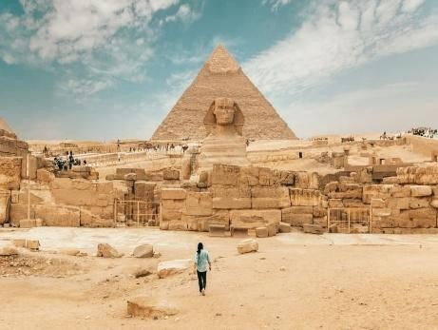
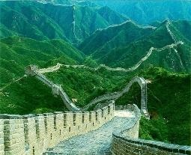
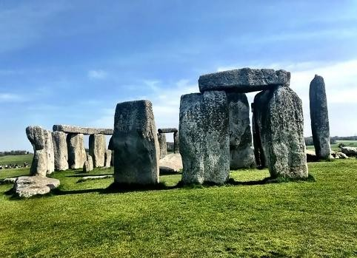

OUR VISION

To be Papua New Guinea's leading travel management company, recognized for service excellence, innovation, reliability, and customer satisfaction.

OUR MISSION

To deliver efficient, cost-effective, and customized travel solutions that exceed client expectations while promoting responsible tourism and contributing to Papua New Guinea's economic development.

OUR CORE VALUES
- Integrity, We conduct our business with honesty, transparency, and professionalism.
- Excellence We strive to exceed expectations through quality service and continuous improvement.

- Customer Focus Our clients are at the center of every decision we make.
- Reliability We deliver dependable services and maintain the highest standards of accountability.

- Innovation We embrace technology and industry best practices to improve customer experiences.

- Partnership We build strong relationships with clients, suppliers, and stakeholders for mutual success.


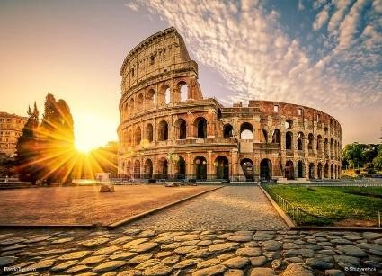


OUR SERVICES

Corporate Travel Management
- Domestic and international air travel bookings
- Executive and VIP travel arrangements
- Travel policy compliance management
- Corporate account management

- Travel reporting and cost analysis
- Group travel coordination

Government and Institutional Travel Services
- Official travel arrangements
- Conference and workshop travel management
- Delegation travel coordination
- Travel logistics support

- Procurement-compliant travel services

Leisure and Holiday Travel
- Customized holiday packages
- Family vacations
- Honeymoon packages
- Cruise and resort bookings
- International travel packages

Accommodation Management
- Hotel reservations

- Long-term accommodation arrangements
- Serviced apartments

- Resort and retreat bookings


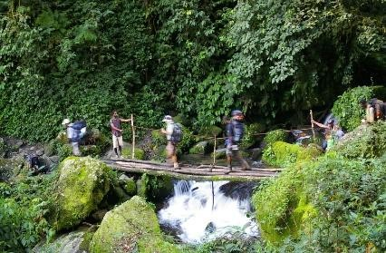


Ground Transportation
- Airport transfers
- Vehicle hire services
- Chauffeur services
- Group transportation solutions

Travel Support Services
- Travel insurance arrangements
- Visa assistance and advisory services
- Travel documentation support
- Emergency travel assistance
- Meet-and-greet services

Tourism and Destination Management
- Cultural tours
- Eco-tourism packages
- Adventure travel experiences
- Corporate retreats
- Incentive travel programs

OUR COMPETITIVE ADVANTAGE

Scenic Travel Agent differentiates itself through:

Local Expertise Strong understanding of Papua New Guinea's travel
environment and logistics requirements.

Personalized Service Dedicated travel consultants who provide customized travel
solutions.
Strong Industry Established relationships with airlines, hotels, transport
Partnerships providers, and tourism operators.
Cost-Effective Solutions Competitive pricing and optimized travel planning.

Professional Team Experienced staff with extensive knowledge of travel
management and customer service.
Rapid Response Efficient handling of urgent travel requests and itinerary
Capability changes.
24/7 Travel Support Emergency assistance and traveller support services.

INDUSTRIES WE SERVE

STA proudly supports clients across various sectors including:

- National Government Agencies
- Provincial Governments

- State-Owned Enterprises
- Mining and Resources

- Oil and Gas
- Banking and Finance

- Telecommunications
- Construction and Infrastructure Non-Governmental Organizations International Development Agencies Educational Institutions
Small and Medium Enterprises

ORGANIZATIONAL STRUCTURE
Managing Director Responsible for strategic leadership, governance, business
development, and stakeholder engagement.
Operations Manager Oversees daily travel operations, service delivery, supplier
management, and quality assurance.
Corporate Travel Consultants Manage client accounts, travel planning, reservations,
and itinerary management.

Finance and Administration Responsible for financial management, procurement,
compliance, and administrative support.

Customer Service Team Provides client support, booking assistance, and travel-
related inquiries.


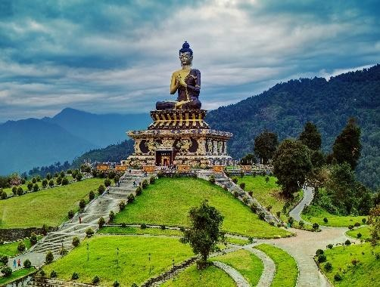
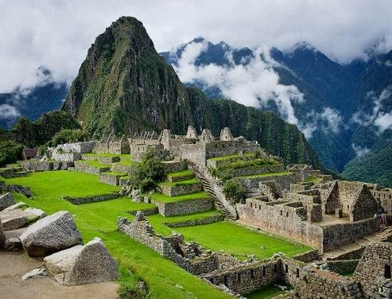

QUALITY ASSURANCE

STA is committed to maintaining the highest standards of service through:

- Continuous staff training and development
- Quality management procedures

- Client feedback and satisfaction monitoring
- Supplier performance evaluation

- Compliance with industry best practices
- Continuous service improvement initiatives

HEALTH, SAFETY AND RISK MANAGEMENT

The safety and well-being of our clients remain a priority. STA implements proactive risk management measures, including:

- Travel risk assessments
- Emergency response procedures

- Traveler support services
- Supplier safety evaluations

- Travel advisory monitoring

CORPORATE SOCIAL RESPONSIBILITY

As a Papua New Guinean-owned company, STA is committed to:

- Supporting local businesses and tourism operators
- Creating employment opportunities

- Promoting sustainable tourism practices
- Encouraging cultural preservation and awareness

- Contributing to community development initiatives


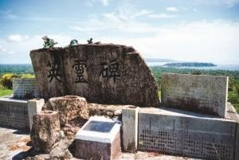
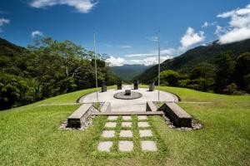

STRATEGIC OBJECTIVES

Over the next five years, STA aims to:

- Expand corporate and government travel portfolios.
- Strengthen digital travel management capabilities.

- Increase partnerships with regional and international travel providers.
- Promote Papua New Guinea as a preferred tourism destination.

- Maintain industry-leading customer satisfaction levels.
- Enhance operational efficiency and service delivery.

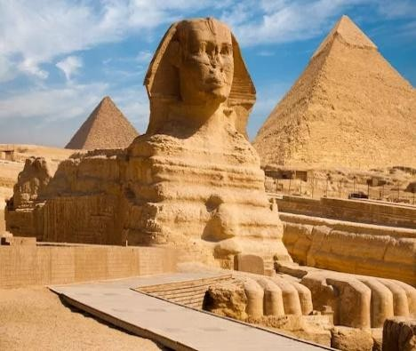



COMPANY INFORMATION
Company Name: Scenic Travel Agent (STA)
Business Type: Travel Management and Tourism Services
Head Office: Port Moresby, National Capital District, Papua New Guinea
Ownership: 100% Papua New Guinean Owned and Operated Industry: Travel, Tourism and Hospitality

CONTACT INFORMATION

Scenic Travel Agent (STA)
Port Moresby, Papua New Guinea Email: stc@scenictravelagency.com.pg Phone: +675 75552542

Scenic Travel Agent (STA) is committed to delivering professional travel solutions, exceptional customer service, and memorable travel experiences for every client, every journey, every time. Enjoy

